

École Intermédiaire
Shuswap Middle School
171 – 30th Street SE Box 1090 Salmon Arm, BC V1E 4P2
Tel 250-832-6031 Fax 250-832-7114 Email sms@sd83.bc.ca
October 2021

Subject: Communicating Student Learning (Report Card Changes)

To Shuswap Middle School Parents/Guardians,

We are excited to share with our SMS community that we are modernizing our reporting practices. As always, we want to support all our learners in their learning journey. In keeping with changes happening province-wide, we are looking to align our reporting practices with the renewed curriculum. Our focus will be on students being aware of their current level of performance and setting goals for continued progress.

To guide their learning journey, students will be setting a learning goal for continued academic and/or social/emotional/behavioral growth. It is important that these goals are shared and discussed with families. Students K-8 across our district will be a part of Student-Parent-Teacher conferences in November to facilitate these conversations. This will constitute their first formal report card. These conferences will provide an opportunity for parents/guardians, as partners, and students, as active participants in their learning, to discuss progress and areas of strength and stretches, and discuss goals. We know that community-building and establishing strong relationships between home and school are what promote learning in the most fundamental way.

Throughout the year, students will be encouraged to keep a portfolio of evidence to show progress toward meeting their goals. Research informs us that students are more motivated to learn when they set personal goals and have clear ideas of next steps in their learning.

Terms two and three report cards will be more traditional. It will provide feedback on their academic progress in all subject areas using the proficiency scale: Emerging, Developing, Proficient, or Extending. This scale is intended to reflect the stage of the student’s learning journey. See below. Letter grades will not be on the report cards.
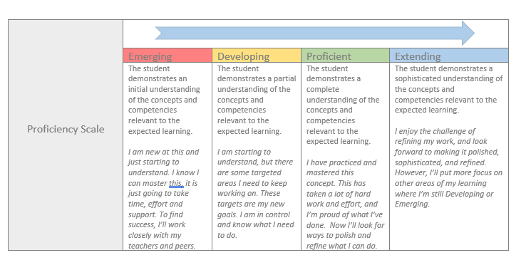

Across our district for K-8 students, our reporting periods will be as follows:

- Interim Report #1 (informal): October
- Goal-setting Conference (formal): November 15-19 (early dismissal on November 18th) – more information to come.
- Report Card (formal): February 17
- Interim Report #2 (informal): April/May
- Final Report Card (formal): June 23

If your child was previously at one of our school district’s elementary schools, these reporting practices will be familiar to you. We are hopeful that our reporting practices help our students to be “assessment-capable learners” that are engaged in their learning journey.

Sincerely,

Sydney Griffith Patti Lemaire Megan Weir

